THE ‘SAFE-LIFE’ BED-EXIT & WELLBEING MONITOR
Introducing contactless bed-occupancy & vital sign monitoring
The Technical Challenge:  Provide an affordable and easy to use contactless monitoring of bed or chair exit and Vital Signs.  Designed to ensure Resident or Patient Wellbeing including sleep analysis and monitoring of bed occupancy.  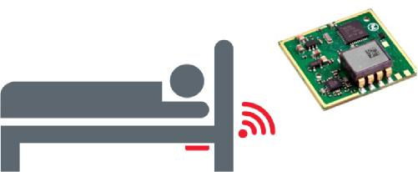  Customer Challenges  Whilst there are numerous techniques to simply monitor bed occupancy the Safe-Life Wellbeing Sensor provides the additional benefit of being able to monitor vital signs. These include heart and respiration rates along with general activity levels thereby collectively providing a long term insight into the person's wellbeing.  Also Polysomnographic (PSG) studies are the golden standard method for providing sleep analysis including obstructive sleep apnea syndrome.  Typical Applications:  - Fall prevention via bed exit detection  - Long term physiological screening  - Sleep analysis  - Physical recovery  Connectivity & Processing  - Direct to Nurse-Call call-point connection  - Direct to ISM Wireless network  - Direct to Wi-Fi Network  - Send to DECT, Wi-Fi and Paging groups  - Log and create reports as required  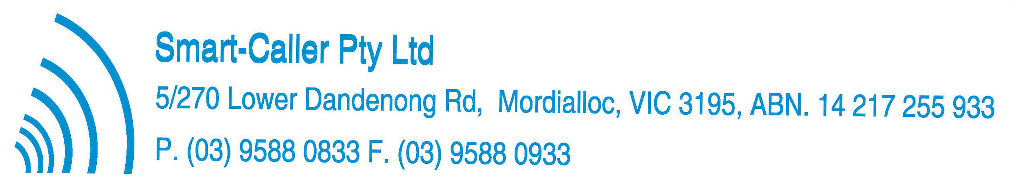 | The Safe-Life Solution:  Safe-Life Wellbeing Sensor A-WBS-01  How it works:  - The sensor is attached to the bed structure.  - The blood flow from a person's heart causes a small movement of the whole body. This is known as the BCG Signal.  - When the bed is occupied, this BCG signal is transferred to the bed structure. The signalling sensitivity is such that the Mattress would not normally impede the delivery of BCG information to the sensor.  - This new Wellbeing Sensor measuring only 84x41x18mm captures these vital sign vibrations, and converts this raw data into structured vital sign data.  - Wireless connectivity ensures that vital sign alerts including bed exit detection can be delivered to the nurse call system head-end for logging, processing and dispatch to responsible Carers both on-site and/or off-site.  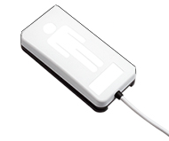  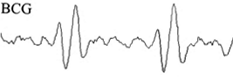  Technical Specification:  - Reports once per second:  - Heart rate (bpm) + Heart rate variability (ms)  - Respiration rate (1/min) + Stroke volume (A.U.)  - Signal strength (a measure of activity) (A.U)  - Accurate beat-to-beat times  - Bed Occupancy/Exit detection  - Wireless connectivity & cloud interface support  - Support software for ease of integration  - Supports Sleep Analysis algorithm development.
CONTENTS SUBJECT TO CHANGE WITHOUTO NOTICE

